Setting up an iCloud Account:

To set up an iCloud you will need to go to Settings, then choose iCloud.

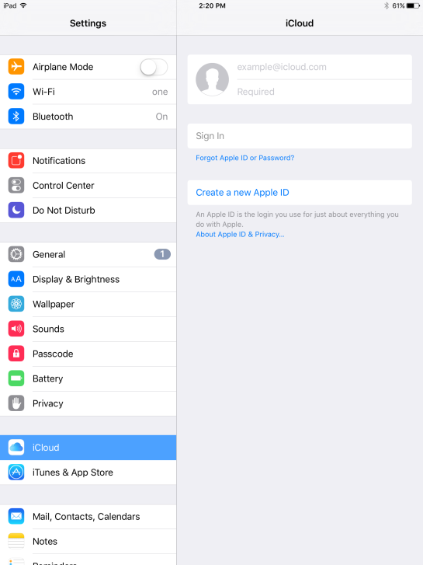

Once here you can log in with an existing Apple ID or create a new one. If you are logging in with an existing ID you will just enter the information in the top line and the password in the second line. If you want to create a new Apple ID you will select “Create a new Apple ID” and follow the prompts.

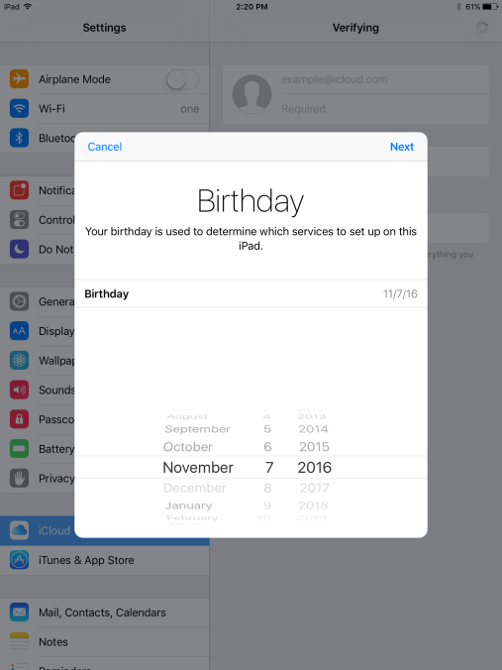

Once you are logged into iCloud you can see that Find My iPad is the last selection in the column and should be turned on.

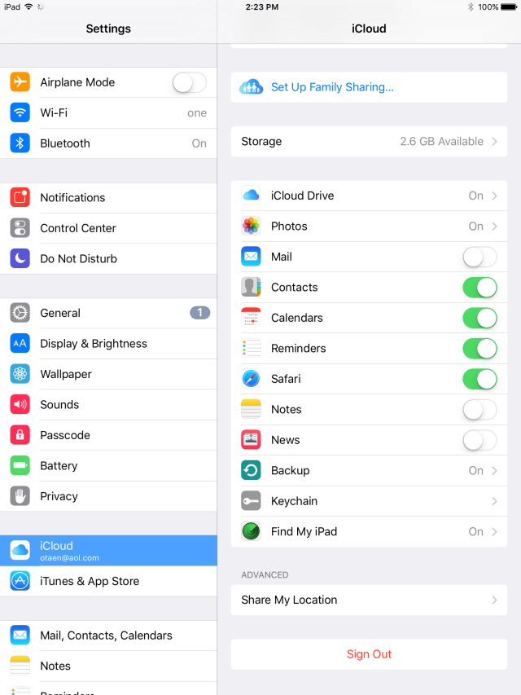

At this point, you can select Find My iPad, and select Send Last Location.

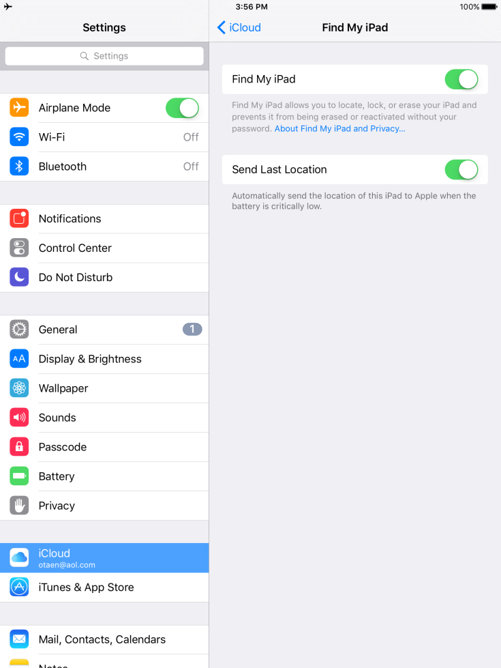

Locating a Missing iPad:

1. Go to iCloud.com on a desktop/laptop computer. There is one in the library for students to use.
2. Login with your Apple ID.

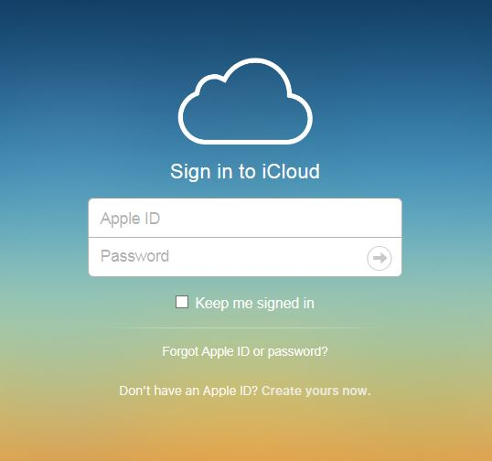

1. Find the “Find iPhone” button and select.

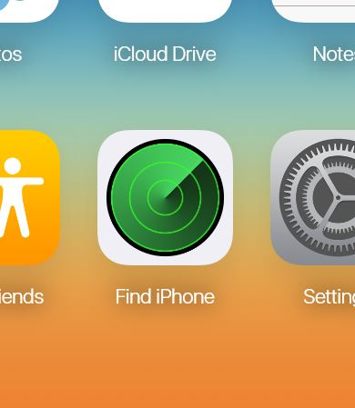

1. If you have more than one device connected to the iCloud account be sure to select the device you are looking for.

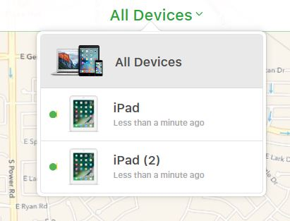

1. You will then, if the iPad is online, be shown a map of the iPad’s location. From here you can also play a sound on the iPad to help locate it. If the iPad is offline, or Do Not Disturb or Airplane Mode has been selected, you may not be able to locate it immediately. We recommend NOT using either of those settings. You should still select Play Sound so that when it does connect the iPad will make a noise.

